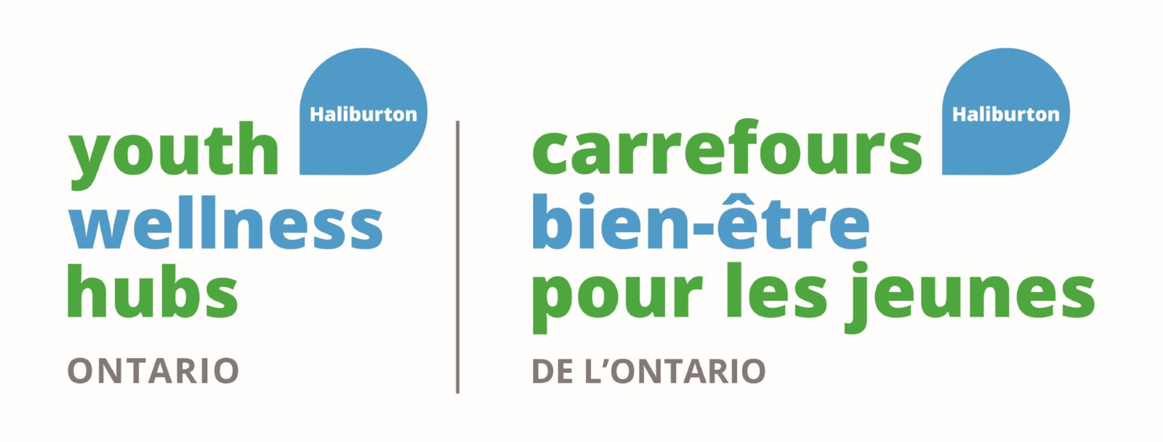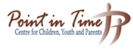
Job Description
Youth Wellness Hub
Medical Administration
Part-time/ One year contract

This Administrative Support person will help The Youth Wellness Hub in providing an inclusive, positive and welcoming space where participants can be social and have access to a broad range of services and support delivered in an integrated fashion. Services include, but are not limited to primary care, sexual health, mental health, employment, tutoring and homework help, life skills, peer support and support with addictions.

We recognize that equitable access to employment is an agent in social change. We welcome and strongly encourage employment of persons with lived experiences, economic challenges, from First Nations, Métis and Inuit peoples, people of all ages, ancestry, citizenship, ethnic origin, place of origin, faith, creed, disability, family status, marital status, all genders and sexual orientation.
Job Summary:
Under the direction of the Youth Wellness Hub Manager, the Medical Administrative Support person is responsible for providing part-time administrative support to the Nurse Practitioner. This position is part–time, three days per week.

Key Responsibilities
Patient reception and communication
- Answers calls that are directed to Nurse Practitioner
- Welcomes patients and supports them with completing My Wellness Passport
- Working as a team member to provide a warm and welcoming environment
- Confirms appointments with patients
- Build and develop relationships with both new and existing patients, physician offices and other healthcare facilities.

Administrative Duties
- Tracks referrals to specialists and external partners
- Inventory of medical supplies
- Uploads documents to electronic medical records system
- Maintain files in medical records system
- Accurately register patients by obtaining complete demographics, insurance information and consent
Coordination and Support
- Handle referral and authorization requests
- Optimize clinic efficiency and capacity
- Consults with supervisor regarding client complaints, serious occurrences, high risk situations, computer problems and conflicts that remain unresolved at other levels
Other Responsibilities
- Reading and writing of reports, minutes, and understanding manuals, program materials, policies and procedures, etc.
- Performs other duties as required by the organization. Ex. participating in community or Hub events.
Education/Qualifications

- High School education – Grade 12
- 1-3 years related experience working in mental Health setting and medical setting
- (Or 1-3 year's experience working in administrative role in mental health or medical setting)
Skills and Assets

- Human service diploma, including Nursing is an asset
- Medical Administrative Assistant training an asset
- Strong communication skills
- Have working knowledge and understanding of indigenous culture and healing practices.
- Time Management
- Proficiency in technology including MS Office and EMR systems experience
- Ability to work independently, and as part of a team
- Exceptional Confidentiality awareness skills and understanding of PHIPA
- Experience working with First Nations, Métis and Inuit and LGBTQ+ peoples is an asset

Work environment and conditions
- In Hub. Remote work available if needed and approved by team
- May connect directly with individuals living with mental health concerns, dual diagnosis and/or addictions, individuals who are experiencing emotional and/or mental health issues and are working towards recovery
- There are multiple competing demands which require time management skills, the ability to be flexible and to prioritize
- Evening/after hours work will be required and possibly, one Saturday a month.

- Working directly with clients can expose staff to risks of physical injury, violence, psychological/emotional injury and infections. All staff are expected to take all precautions to ensure their safety and to reach out to hub staff for support as required.
- Some cleaning is required

HOURS PER WEEK: 21 hours/week
RATE OF PAY: $29.00/hour

Please send cover letter and resume to HR@pointintime.ca
or fax to 705-457-3492 by January 19th, 2025

